
April 2003
y 2002
18-009-0403

Animal Flea and Tick Collars are NOT for Human Use!

Wearing flea & tick collars is harmful to the health of the soldier, is a violation of federal laws, and has unproven effectiveness.

Skin lesions on a soldier’s legs caused by wearing flea & tick collars.

• Background. Numerous national news media reports indicate that well-meaning citizens or citizen groups are sending animal flea and tick collars to our troops to be worn in the Iraqi Theater of Operations. They suggest that these collars can be worn by soldiers for protection from such annoyances as “sand fleas.”
• Animal flea and tick collars contain a wide variety of pesticides that can be absorbed into the skin in toxic amounts. These pesticides include carbamates (e.g. carbaryl, propoxur), organophosphates (e.g. tetrachlorvinphos), insect growth regulators (e.g. methoprene), and formamidines (e.g. Amitraz). They may cause severe skin reactions and have the potential to cause systemic poisoning.
• Here’s how it happens: Sweat secreted through pores from glands in the skin can leach out pesticides, and possibly other chemical ingredients, from flea and tick collars in large quantities. This sudden, massive dose of pesticides can result in direct skin damage (like the burns seen in these photographs), or possible internal damage due to absorption of those pesticides back through the skin’s pores.
• Sweat can even draw pesticides from flea and tick collars right through fabrics, so wearing collars on the outside of pants or socks is not a safe practice. The same goes for canvas desert boots.
• Flea and tick collars are not as hazardous for dogs and cats because these animals do not sweat. This is why they must pant to cool off. Even so, flea and tick collars can even be harmful to animals if not used in strict accordance with label directions and precautions.

• It is not surprising that animal flea and tick collars are not registered for human use by either the Environmental Protection Agency (EPA) nor the Food and Drug Administration (FDA). It is therefore against the law to use such pesticide devices in a manner that is inconsistent with the label instructions.
• In addition, there is no evidence that wearing flea and tick collars in any manner is useful in preventing attack of humans by disease-bearing or nuisance insects.
For optimum protection from disease-bearing and nuisance insects and other arthropods, soldiers should use the DOD Insect Repellent System.

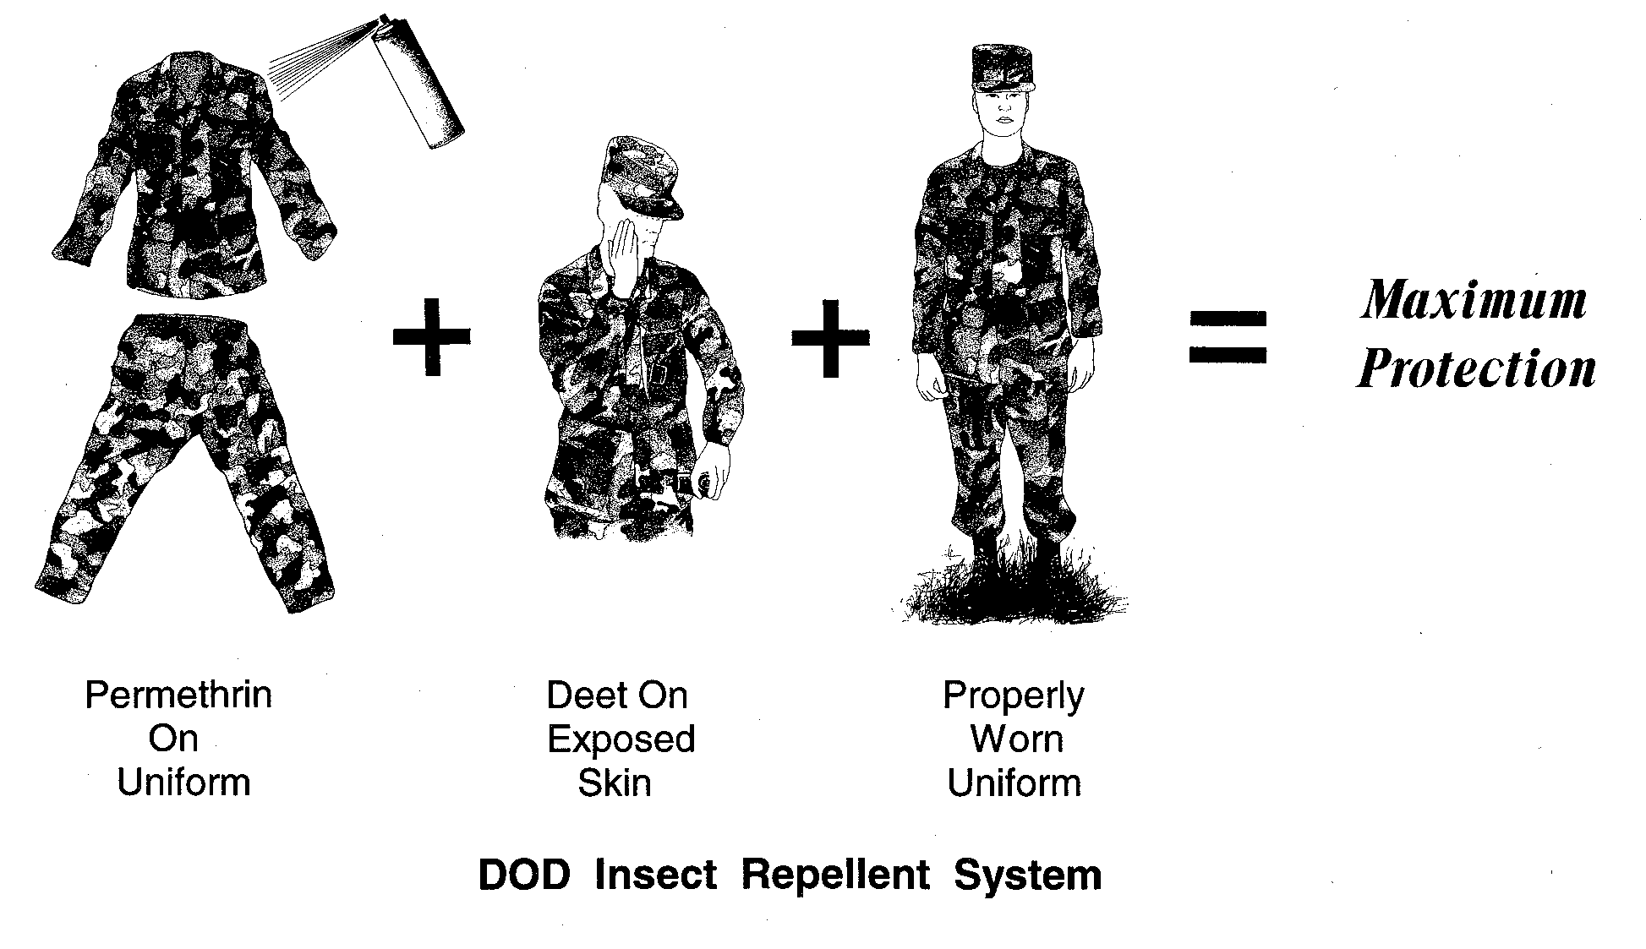

• Treat uniform with permethrin clothing repellent BEFORE putting it on. Use the Impregnation Kit (IDA, NSN 6840-01-345-0237), one kit treats one uniform and the treatment lasts for the life of the uniform (at least 50 washes), OR Aerosol can (NSN 6840-01-278-1336), one can treats one uniform and the treatment lasts through 5-6 washes). Follow all label directions. The aerosol spray is available commercially under a variety of labels including Repel® Permanone.
• Apply a thin coat of long-lasting DEET insect repellent lotion to all EXPOSED skin. Use NSN 6840-01-284-3982. One application lasts for up to 12 hours, depending on the climate. Follow all label directions. This product is also available commercially as Ultrathon™. It was rated the number one skin repellent by Consumer Reports (May 2003).
• Wear uniform properly: roll sleeves down, tuck pants into boots, and tuck undershirt into pants.
• The “perceived” effectiveness of wearing a flea/tick collar around the pant leg is that securing the pant leg closed with the flea/tick collar simply prevents access of the biting insects (e.g. sand fleas, a colloquial term generally referring to biting midges, gnats or other types of tiny flies) to the skin. Keeping pants tucked firmly down into the boots with the blousing cords drawn tight, will afford the same protective effect. Permethrin on the uniform fabric kills most insects (and other arthropods such as ticks) upon contact, and is the most important means of protection.

U.S. Army Center for Health Promotion and Preventive Medicine
Entomological Sciences Program
5158 Blackhawk Road
Aberdeen Proving Ground, Maryland 21010-5403
http://chppm-www.apgea.army.mil/ento

